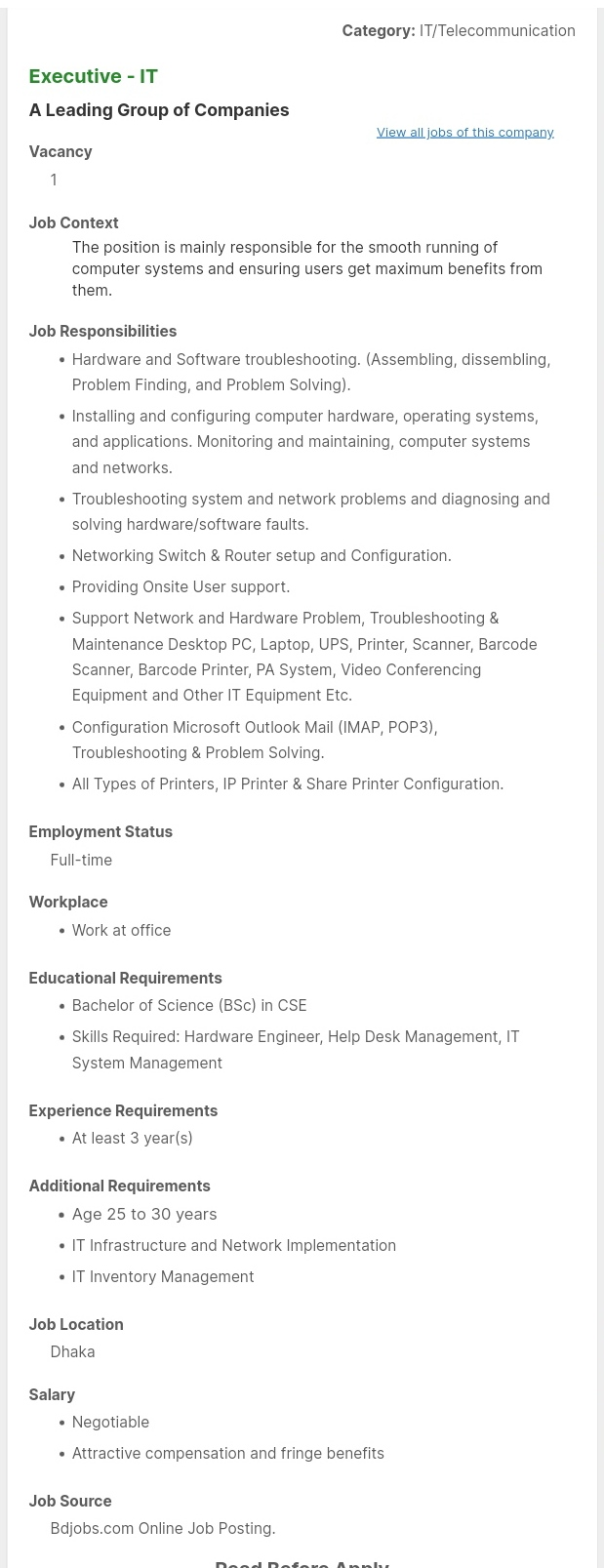

**Worksheet on Job Advertisement Analysis**

1. What is the name of the company you are applying to?

|  |
| --- |
| A Leading Group of Companies. |

1. What is the name of the post you are applying for?

|  |
| --- |
| Executive-IT. |

1. What problem is the company trying to solve/ what are they selling?

|  |
| --- |
| Smooth running of computer systems and ensuring users get maximum benefits from them. |

1. To whom are you sending this letter? Name/post

|  |
| --- |
| MD. Hasib Ahmed  Manager |

1. What is the company address?

|  |
| --- |
| Dhaka, Bangladesh. |

1. How did you discover the job was available?

|  |
| --- |
| bdjobs.com |

1. What is the educational requirement mentioned in the job?

|  |
| --- |
| Bachelor of Science (BSc) in CSE |

1. Why are you interested in this particular job and company?

|  |
| --- |
| I am interested in this job because I can see that, in this role, my skills could help solve this problem within your company and I also see an opportunity for me to learn and grow these skills. |

1. Determine the three areas that are the highest priority to the company/the post.

|  |
| --- |
| * Hardware and Software troubleshooting. * Installing and configuring computer hardware, operating systems, and applications * Networking Switch & Router setup and Configuration. |

1. What technical skills are required for this job?

|  |
| --- |
| Hardware Engineer, Help Desk Management, IT System Management |

1. What soft skills/type of personality is needed for this job?

|  |
| --- |
| 1. Communication. 2. Attention to detail. 3. Creativity. 4. Teamwork & cooperation. 5. Time management 6. Training and teaching. |

1. List down the technical skills that you have developed so far. (name of PLs, computer literacy, etc.)

|  |
| --- |
| Advanced Operating System, Network Resource Management, Digital System Design, Simulation & Modeling, Robotics Engineering. |

1. List down three of your soft skills that you consider your strength as a human being.

|  |
| --- |
| 1. Communication 2. Teamwork & cooperation. 3. Time management. |

Executive-IT

A Leading Group of Companies.

Dear Concern,

In response to the advertisement published on 14 Oct, 2020 on Bdjobs.com, I am writing to express my interest for the position of Executive-IT in your esteemed company, A Leading Group of Companies.

Recently I have achieved my Bachelor’s Degree in Computer Science and Engineering, majoring in Computer Engineering from the American International University-Bangladesh (AIUB) with a Good result, I would like to bring my knowledge, skills and commitment to your company’s innovative environment. During my education, I have gained the necessary knowledge that come with the position including Hardware Engineer, Help Desk Management, IT System Management, Advanced Operating System, Network Resource Management, Digital System Design, Simulation & Modeling, Robotics Engineering, Java, Python.

.

My internship at American International University-Bangladesh also afforded me with the crucial skills to work with some of the best professionals in the recruitment and Computer Engineering. During the course of my four months internship, I developed enthusiasm and passion for Software Development and the internship has subsequently convinced me that Computer Engineering is my true calling.

For additional details regarding my qualification and expertise, please review my resume as attached with this letter. I will be reached via email anytime and phone from 9am to 9pm on the weekdays. Thank you for taking the time to consider this application and I look forward to hearing from you at your earliest convenience.

Yours sincerely,

Siam

Nokibul Arfin Siam

01642580210